# Complete Use Cases

|  |  |
| --- | --- |
| **Use Case ID** | **CPv5-001 Pull Mentee Reports** |
| **Update for** | **_____** |
| **Description** | The administrator pull mentee reports. |
| **Actor** | Administrator |
| **Pre-conditions** | ●     The administrator is logged into the system. |
| **Steps** | 1. The use case begins when the administrator clicks on the menu for mentee reports. 2. The system is redirected to a page with the listing of mentees with information such as name, email, school, user status, project assignation, etc. 3. The use case ends when the administrator navigates to another page. |
| **Post-conditions** | ●     **_____** |
| **Alternative Actions** | * At step 2, the administrator can click a column of the report, and the system will render the report but sorted by the column just clicked. * At step 2, the administrator can input information by any of the column, and the system will render a new report filtered by the information just entered. * At step 2, the administrator drags and drop a column in the position of another column and the system will render the report with the new column order. |
| **Exceptions** | * NONE |

|  |  |
| --- | --- |
| **Use Case ID** | **CPv5-002 Pull Mentor Reports** |
| **Update for** | **_____** |
| **Description** | The administrator pull mentor reports. |
| **Actor** | Administrator |
| **Pre-conditions** | ●     The administrator is logged into the system. |
| **Steps** | 1. The use case begins when the administrator clicks on the menu for mentor reports. 2. The system is redirected to a page with the listing of mentors with information such as name, email, employers, user status, etc. 3. The use case ends when the administrator navigates to another page. |
| **Post-conditions** | ●     **_____** |
| **Alternative Actions** | * At step 2, the administrator can click a column of the report, and the system will render the report but sorted by the column just clicked. * At step 2, the administrator can input information by any of the column, and the system will render a new report filtered by the information just entered. * At step 2, the administrator drags and drop a column in the position of another column and the system will render the report with the new column order. |
| **Exceptions** | * NONE |

|  |  |
| --- | --- |
| **Use Case ID** | **CPv5-003 Pull Ticket Reports** |
| **Update for** | **_____** |
| **Description** | The administrator pull ticket reports. |
| **Actor** | Administrator |
| **Pre-conditions** | ●     The administrator is logged into the system. |
| **Steps** | 1. The use case begins when the administrator clicks on the menu for ticket reports. 2. The system is redirected to a page with the listing of tickets with information such as Date Created, Status, Closed Date, etc. 3. The use case ends when the administrator navigates to another page. |
| **Post-conditions** | ●     **_____** |
| **Alternative Actions** | * At step 2, the administrator can click a column of the report, and the system will render the report but sorted by the column just clicked. * At step 2, the administrator can input information by any of the column, and the system will render a new report filtered by the information just entered. * At step 2, the administrator drags and drop a column in the position of another column and the system will render the report with the new column order. |
| **Exceptions** | * NONE |

# Use Case Model

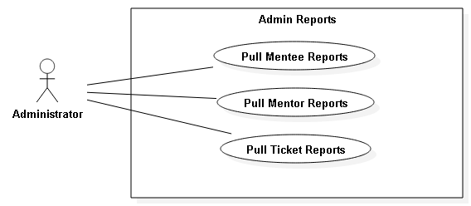

# Static Model

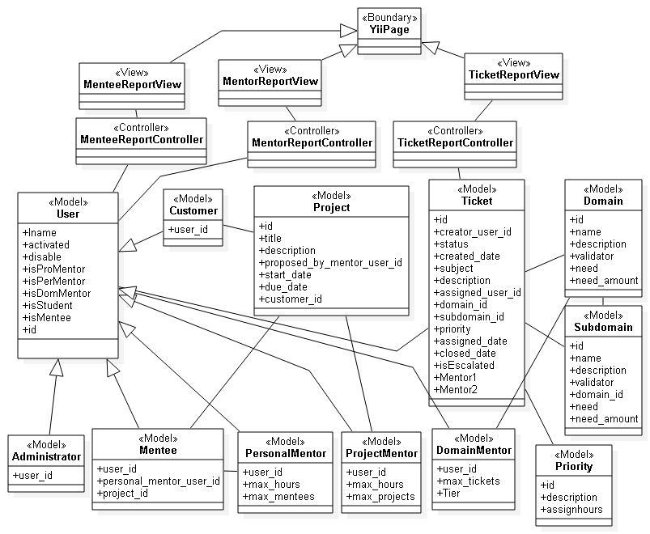

# Dynamic UML Model

